Advice for Parents on Digital Learning from ACC

Learning online is new for many pupils and parents. This document provides advice on how to setup for learning, to be part of online meetings and access learning in Google Classroom. The key points are:

For pupils:
- find a quiet space
- use headphones if you can
- place your device so the camera doesn’t show too much of your home (to protect your privacy)
- behave in the lesson as you would be expected to in school
- be kind and considerate of others
- follow up tasks will be in Google Classroom – you can ask questions of your teacher there

For parents:
- help your child find the best place to work (if possible, not a bedroom)
- be on hand, if you can, to help if needed
- take an interest in your child’s work and the work left for them to complete in Google Classroom
- Don’t interrupt the lesson. If you require to speak to the teacher make a separate appointment through emailing the staff member.

Google Meet - Live Lessons from your home
Pupils - Getting set up
First of all, if you are not comfortable with being on camera to speak with your teacher, let him or her know using an email or private message in Google Classroom, so that other arrangements can be put in place.

Using Google Meet is inviting someone into your home. You need to think carefully about the view from your web camera and how you are set up at home for learning online. Here are some top tips.

- Be dressed suitably - no PJs - get dressed as you would be happy to be seen outside of your home.
- Sit somewhere with your back towards the wall. This will reduce how much of your home is in the camera frame.
- Turn the TV and other distractions off. Try to find a space which is quiet. Don’t worry - we know this might not always be easy for everyone to do.
- If you have some headphones, use them. You might need to change the meeting settings after you plug-in your headphones. This will work even better if they have a microphone.
- Choose somewhere with good light but don’t have your back towards a window if you can avoid it. Too much light can make it difficult for others to see you on your camera.
- Have your device on a table rather than on your knees. If you don’t have a table, use cushions under your device to make yourself more comfortable.
- Have some paper/jotters handy with a pen or pencil so you can write notes if you need to. You could also use Google Keep or Docs to write short notes with your device during your meeting.
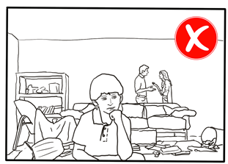 | 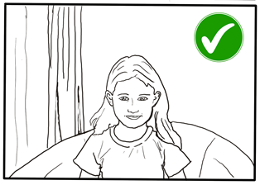
Pupils - Connecting to your meeting
Your teacher will set a time for your meeting in Google Classroom. This is also where you will find the link for the meeting when it starts. Your teacher will be the first person in the meeting room and will be the last person to leave it.
Your teacher will start recording the meeting as soon as it begins. The recording of the meeting can be made available to pupils who couldn’t attend. If your teacher has forgotten to start the recording politely remind him or her to start recording using either chat or your microphone.
Top Tips for your meeting
- Visit your Google Classroom to get the meeting link just before the meeting is due to start.
- Go to the meeting link.
- Mute your microphone before you enter the meeting. You can also switch off your camera if you wish.
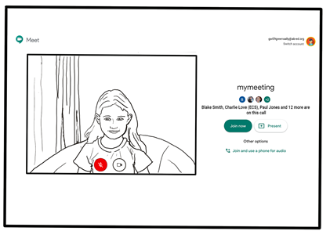
- Click Join now to enter the Google Meet. Don’t click Present.
- Once connected, listen carefully to your teacher. You can use the chat to ask questions or unmute your microphone and ask your question. You should mute your mic again after you have asked your questions.
- In your Meet, be kind and considerate of other people. The Meet is just like being in school and you need to behave appropriately. Your teacher may remove you from the meeting if you don’t do so. If you are removed from a meeting, the headteacher or another member of senior staff may discuss this with you and your parents/carers.
- Remember, the meeting is being recorded. The REC in red on the top left of the page tells you that recording is happening.
- When the call is complete, disconnect by clicking the red “hang up” button.

Remember to check Google Classroom after the meeting for any assignments that your teacher has set for you.
Page Break
Parents - Helping your child to set up & connect
Our tips for helping your child to be part of an online video lesson.
- Remind your child that they need to behave appropriately in online lessons. Encourage them to be polite and respectful during the call. Be aware that inappropriate behaviour may result in your child being removed from the meeting and a follow-up discussion with school staff.
- Position the computer/device in a room where you can monitor their activity, preferably not a bedroom.
- Keep the background clear, with good lighting and sound (see our pupil tips above).
- Information about who is hosting the lessons, what the lesson will be about and what tasks are set following it will all be shared in your child’s Google Classroom. The link to the meeting will be shared in your child’s Google Classroom just before the meeting is due to start.
- Your child may need support in setting up Google Meet (https://meet.google.com), connecting their headphones, if they have them, and selecting the camera.

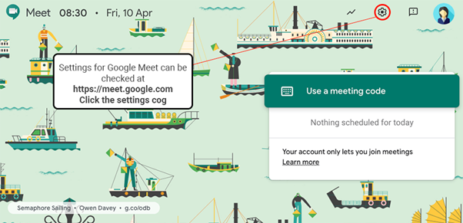

Page Break
Audio Settings can be adjusted - select your mic and headphones
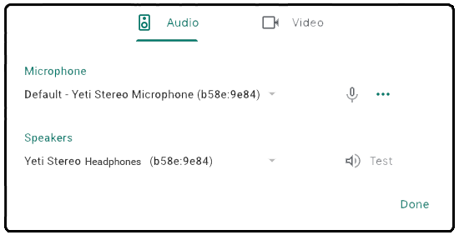
Camera settings can be adjusted on the Video tab

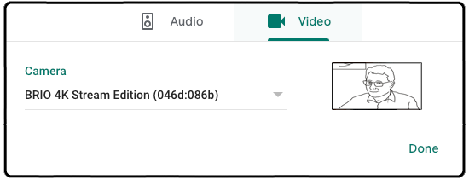
Help your child to do this and check the preview of the webcam before your child joins the meeting.
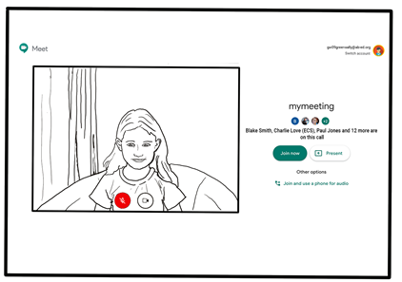

- If you can, it is helpful for you to take an interest in your child’s lesson and stay close by so you can assist if needed.
If you are subscribed to Guardian notifications from your child’s Google Classroom, you will be emailed this information.

- To protect your own family’s privacy and that of others, we ask that participation in online meetings is kept to your child, their class and teacher. All meetings will be recorded by the class teacher.

If you have any concerns about the use of Google Meet or the content of live lessons, you can contact your school (details here). To ensure the safety of all participants, we ask all our teachers to record their live lessons.

